

**STANDARD OPERATING PROCEDURE**

**Do not Photocopy**

**Document Information Classification: Unrestricted**

|  |  |
| --- | --- |
| **Title:** | **Return, Re-use and Disposal of TRE Assets** |
| **Effective Date:** | **07 Jun 2019** |
| **Reference Number:** | **SOP-05-02** |
| **Version Number:** | **3.3** |
| **Owner:** | **Information Security Manager,** |
| **Review Date:** | **20 Mar 2020** |

Table of Contents

1. Purpose 3

2. Scope 3

3. Responsibilities 3

4. Procedure 4

4.1. Returning Assets 4

4.2. Re-assigning Assets/Relocating Assets 4

4.3. Repair, disposal or re-use of hardware 4

4.3.1. Procedure for re-use or disposal 4

4.3.2. Procedure for Repair 5

4.3.2.1. On-site repairs 5

4.3.2.2. Off-site repairs 5

4.3.2.3. Updating the Asset record 5

5. Cross-referenced ISMS Documents 5

6. Appendices 6

6.1. Q-Pulse Guidelines for Managing Assets 6

6.1.1. Identifying Assets Owned by an Employee 6

6.1.2. Updating the Asset Record 7

6.1.3. Adding Notes To the Asset Record 8

1. Purpose

An inventory of the TRE assets should be maintained and processes should be established to manage the return of the organisation’s assets from departing employees and ensure proper handling when assets are deleted or destroyed.

This document defines the process for maintaining the asset inventory and managing assets through return, repair, re-use or disposal to ensure that any sensitive information stored on the asset cannot be accessed by unauthorised individuals.

1. Scope

This procedure covers all tangible assets that have been introduced into the TRE which includes:

* Information Assets – TRE Data
* Information Assets - System information
* Software Assets
* TRE Infrastructure
* Physical assets
* Services:

The following CHI asset types are also in scope for this procedure. However, the management of these groups of assets has no direct impact on the TRE and can be considered ‘best-efforts’.

* Portable Electronic Devices

The following groups of assets are out of scope of this procedure:

* Information Assets - Documents
* People

1. Responsibilities

The Information Security Manager (ISM) is responsible for:

* Authorising disposal, re-use or repair of hardware

The Line Manager is responsible for:

* Informing the CHI Administration team if assets are re-assigned or relocated
* Identifying and recovering all assets assigned to a member of their team at the point of leaving

CHI Staff Administration or TRE Operations is responsible for:

* Managing the appropriate asset records in Q-Pulse

The Q-Pulse Administrator is responsible for:

* Updating the managed lists for asset locations

1. Procedure
   1. Returning Assets

When a member of staff or a student leaves their role within the organisation, as part of the actions on the Exit Checklist (FORM-004), their line manager must ensure all assets allocated to the leaver are returned. The assets can be identified from Q-Pulse.

When CHI assets are received the line manager will confirm with CHI Staff Administration who will update the asset record to indicate that the assets are no longer assigned and return the spare assets to the CHI pool.

* 1. Re-assigning Assets/Relocating Assets

An existing asset may be re-assigned to a different individual or re-located within the organisation (e.g. to a different building or different team).

Any changes to TRE assets will be notified to [TRE Operations](mailto:tre-operations@manchester.ac.uk) who will update the asset record with the new details.

The line manager of the person using CHI assets will report any changes to CHI Staff Administration who will update the asset record with the new details.

* 1. Repair, disposal or re-use of hardware

The term “repair” refers to fixing damaged hardware whilst ensuring that the storage of data is not compromised.

The term “re-use” refers to the re-allocation of an asset item to a department, group or project that falls outside of the TRE scope. Where computing hardware within its usable lifespan is surplus to requirements reasonable efforts shall be made to see if any other group or individual within The University of Manchester is able to make use of the equipment where this is permitted by any contractual agreement under which the equipment was purchased or supplied.

The term “disposal” refers to the scrapping or destruction of TRE hardware or software.

The decision of whether hardware should be submitted for repair, reuse or disposal will be made by the ISM. No decision will be required from the ISM where only CHI asset types are involved.

* + 1. Procedure for re-use or disposal

The equipment should be made available for re-use or disposal through a request to The University of Manchester IT Service Desk.

[IT Service Catalogue - Hardware/Infrastructure](https://supportcentre.manchester.ac.uk/ServiceDesk.WebAccess/ss/search/search.rails?search_type=ServiceCatalogue&taxonomy_path=Service%20Catalogue%5CHardware%20%2F%20Infrastructure%5C&requesting_user=3f5bcbb0-263b-43a0-9a56-14299017b944&s=)

Prior to the handover of any assets to IT Services, a number of activities should be completed, including

* Making a secure copy of any data that needs to be retained
* Recording software license information/keys
* Securely erasing all data on all storage media. This should be done at the level of British HMG Infosec Standard 5
* Managing the collection of hardware by The University of Manchester IT Services  
  + 1. Procedure for Repair

Repairs can be completed on-site or off-site. The steps that should be followed will be different depending upon which option is necessary.

* + - 1. On-site repairs

Actions include:

* Booking an on-site repair.
* Direct supervision of the repair process to ensure no sensitive data is accessed
  + - 1. Off-site repairs

Actions include:

* Booking an off-site repair. This includes managing the delivery of hardware to the repair service provider and receipt of hardware after the repair

If the hardware can be repaired with the storage media removed, actions include:

* Removing all storage media that is part of the hardware to be repaired
* Replacing storage media after completion of the repair

If the hardware can’t be repaired with the storage media removed, actions include:

* Creating a copy of sensitive data on encrypted external media. The encryption keys for the external media should be securely recorded. The external media should be stored in a secure location.
* Erasing sensitive data on the hardware to be repaired. This should be performed at the level of British HMG Infosec Standard 5
* Restoring sensitive data after the repair
* Securely erasing the data copy on the external media. This should be done at the level of British HMG Infosec Standard 5
  + - 1. Updating the Asset record

A note should be added to the Q-Pulse asset record to indicate that the asset is being repaired and is not available. A further note should be added once the repaired item is returned.

1. Cross-referenced ISMS Documents

|  |  |  |
| --- | --- | --- |
| Number | Type | Title |
| FORM-004 | ISMS\Forms | New starter and leaver asset and IT account checklist |
| SOP-01-04 | ISMS\SOP\Personnel & Training - SOP | Maintaining Person Records |
| SOP-07-03 | ISMS\SOP\Information Governance - SOP | Disposal of Sensitive Documents |
| ISMS-09-11 | ISMS\Policy & Guidance\TRE System Administration - policy & guidance | TRE Data Backup Policy |

1. Appendices

Suitable software for erasing data:

Eraser: [A security tool to remove sensitive data from your Windows hard drive](http://sourceforge.net/projects/eraser/)

* 1. Q-Pulse Guidelines for Managing Assets

Only CHI Staff Administration or the TRE Operations team can update the asset records within the Q-Pulse Assets module. Line managers can view all assets in the system. This section describes in further detail the steps necessary to complete these responsibilities.

* + 1. Identifying Assets Owned by an Employee
* To perform this type of search within Q-Pulse, open the Assets module, and click on ‘Advanced’ within the search box.

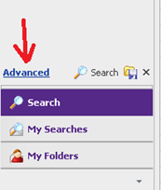

* This will open the ‘Advanced Search’ dialog.
* Click on the ‘X’ icons to remove any existing search queries.
* Click the ‘And/Or’ link which opens up a query dialog of three fields.
* From the first field drop-down menu, select ‘Assigned To’ (found within the Asset Details section).
* Leave the second field set to ‘equal to’.
* The third field drop-down will then display People records, and from here select the name of the person leaving.

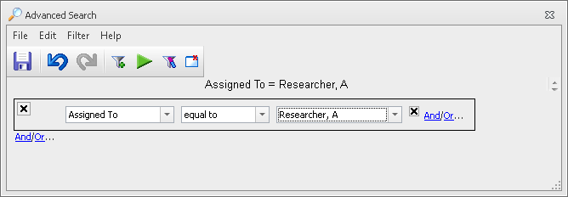

* Finally, click on the ‘Play’  icon to run the search query. All assets assigned to the selected person will then be listed.
  + 1. Updating the Asset Record
* Open the Asset record from the Assets module. To limit the number of records displayed on the Asset module use the Advanced search.

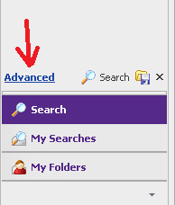

* In the example below the asset list will be restricted to items of Asset Type – ‘Data Storage’

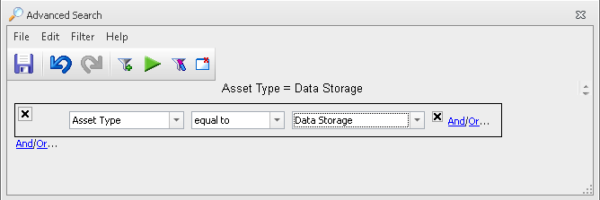

* Open the Asset record to be updated by double clicking on the item record on the asset list. This will display the detailed asset record.

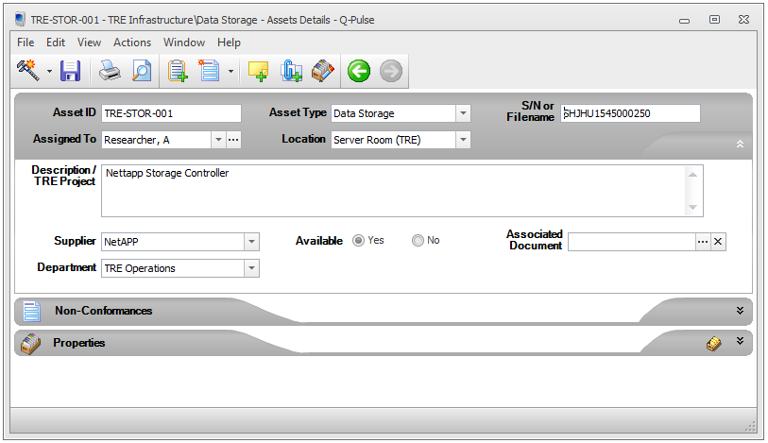

* The fields that can be updated are:
* **Assigned To:** the person who has possession of the asset is responsible for its usage.
* **Location:** the room/area in which the asset can be found
* **S/N:** the asset’s serial number (put “N/A” if not applicable)
* **Description:** A summary of the asset information, any projects the asset belongs to and any supporting information.
* **Supplier:** Either type in or select the supplier (manufacturer) from the list. If the supplier doesn’t already exist it can be added to the list.
* **Department:** where appropriate, select the department to which the asset belongs
* **Available:** Yes/No – Set to ‘No’ if the asset is assigned and being used. If ‘No’ is selected a reason will need to be selected from the dropdown list. For some items held in stock or for long-term loan, e.g. laptops, it’s possible that the asset will be assigned to a person, but could still state ‘Yes’ in the available section to indicate the item hasn’t been loaned out yet.
* **Associated document:** The asset can be linkedto an active document in Q-Pulse – e.g. maintenance document/user guide.
* **Properties:** Expand the section and click to view the available fields. The properties section should be used to record any additional information that is useful for the asset – this may include attaching manufacturer’s documents/URLs, or the IP address and purchase date.

Note: If a new asset location is identified the CHI Administration team will inform the Asset Process Owner who will confirm whether the new details can be added. If approved the CHI Administration Team will request the Q-Pulse Administrator to add the new asset location.

* + 1. Adding Notes To the Asset Record

To add notes to the asset record:

* Click on the Properties icon located on the Properties tab of the asset record.
* This display the ‘Additional Fields’ dialog.

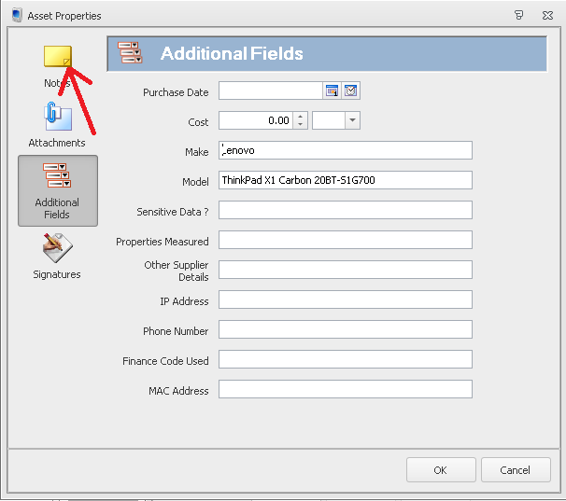

* Click on the ‘Notes’ icon to display the ‘Notes’ dialog

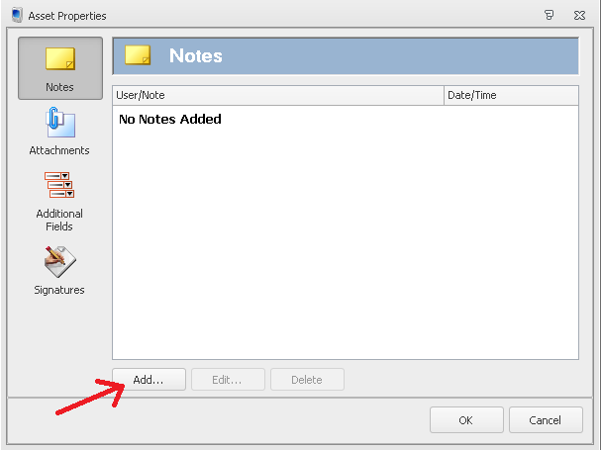

* Click on the Add button to add a Note to the record.
* This displays the Add/Edit Note dialog.

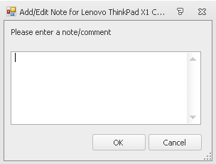

* Type in the note details
* Press OK to close the Note and OK to return the Asset record.
* Save the Asset record by clicking on the Save icon.